Phase 5

Lesson 3

**Format and Mount an EBS Volume**

Steps:

1. Attaching an existing EBS volume

2. Mounting the EBS volume

3. Unmounting the EBS volume

Step 1: Attaching an existing EBS volume

* Select an existing volume and click on *Attach Volume*
* Select the instance

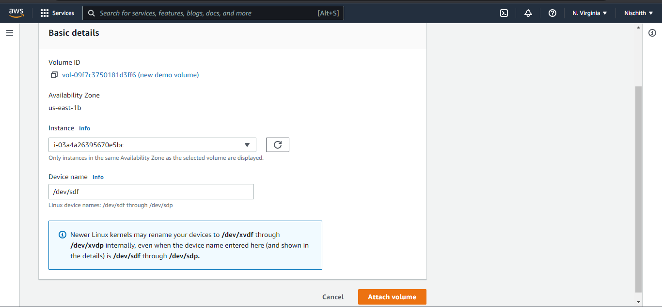

**Step 2:**  Mounting the EBS volume

* Login to your EC2 instance and list the available disks using the following command:

ldblk

* Use the following command to check if the volume has any data:

sudo file -s /dev/xvdf

* Use the following command to format the volume to ext4 filesystem:

sudo mkfs -t ext4 /dev/xvdf

* Use the following command to create a directory to mount the volume:

sudo mkdir /newvolume

* Use the following command to mount the volume:

sudo mount /dev/xvdf /newvolume/

* Check the disk space using the following command:

cd /newvolume

df -h .

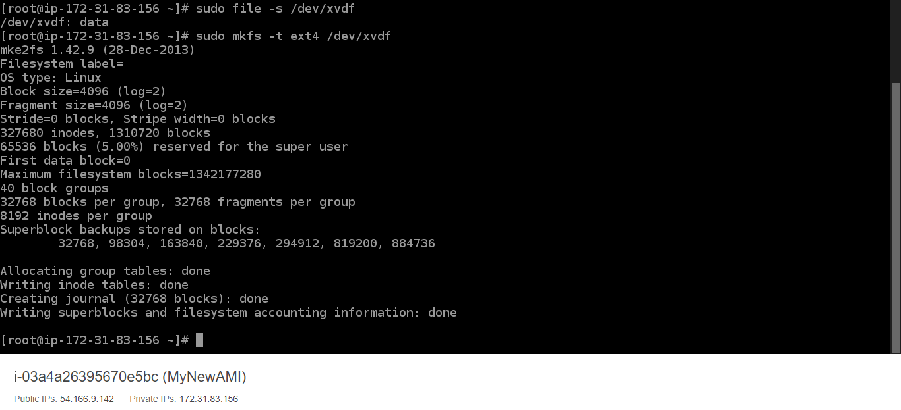

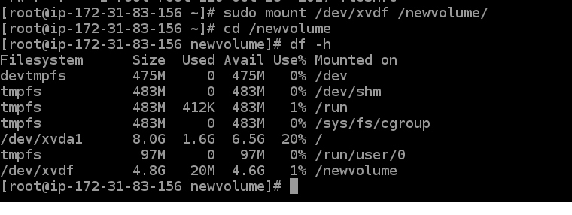

**Step 3:** Unmounting the EBS volume

* Use the following command to unmount the volume:

*umount /dev/xvdf*

**